Electrical Power System Architecture
Norbert Doerry
August 22, 2026
- Introduction
An architecture defines patterns for how the elements of a system can connect and interact. As described in IEEE Std 45.3 most shipboard electrical power systems can be classified as radial architectures, ring architectures, or zonal architectures. Other hybrid architectures are possible, but are not commonly found. The elements of an electrical power system as defined by Doerry and Davis (1994) and Doerry et al. (1996) are:
- Power Generation: Converts fuel or other source of energy into electrical power
- Power Distribution: Provides electrical connection between other modules, includes fault protection.
- Power Conversion: Converts electrical power from one type to another type and used to interconnect power systems. A power type is described by the frequency (or dc), number of phases, voltage, and grounding system.
- Energy Storage: Stores electrical energy; charging and discharging are both accomplished through electrical interfaces (possibly the same interface).
- Platform Load (or Load): All the loads listed in the load list of the ship’s Electric Power Load Analysis (EPLA) with the exception of equipment associated with a propulsion motor.
- Propulsion Power (or Propulsion Motor): Converts electrical power into mechanical power for the purposed of propelling the ship.
- Power Management (or Power Control): Comprised the software, and possibly the hardware, not part of other elements, and needed to successfully operate the electrical power system.
These elements are implemented in the hardware and software of a corresponding module. The interconnections between the modules are in the form of power cable connections (the power cables are part of power distribution), and control system signals.
Most ships have multiple electrical power systems interconnected with power conversion. Two electrical power systems interconnected with power conversion may belong to the same separately derived system (see NFPA 70) or may belong to different separately derived systems. With two separately derived systems, a ground fault on one should not result in a ground fault on the other.
This document focuses on medium and low voltage ac distribution systems as well as low voltage dc distribution. For a discussion on medium voltage dc distribution, see Doerry and Amy (2016); medium voltage dc distribution systems have not yet been implemented onboard commercial ships.
The choice of architecture is also influenced by regulations and class society rules. Both should be consulted to help ensure compliance. Many regulations and rules have been written based on an assumption of using a radial architecture; special approvals may be required when using a ring or zonal distribution architecture.
- Radial architecture
  - Design
In a radial architecture, every switchboard (power distribution) connects to a source (power generation, power conversion, or energy storage). All loads are powered via a single switchboard (power distribution) at any given time, possibly via intermediary load centers (power distribution) and power panels (power distribution). Power flow from the switchboard to the load is unidirectional. Switchboards are inter-connected with bus ties (power distribution) to enable powering a switchboard from the source on another switchboard. Critical loads have a bus transfer (power distribution) that enables switching its supply connection from one switchboard to another. These bus transfers can be manually operated (MBT), automatically operated (ABT), or implemented with power electronics (SSABT). The bus transfer may be located at the load, at the input to a power panel, or at the input of a load center. Loads connected to each switchboard may be located anywhere onboard the ship. If all the switchboards are configured such that they are all electrically connected, then the electrical power system is said to be connected for parallel plant operation. If the switchboards are configured such that the electrical power system is operated as two or more independent systems, the electrical power system is said to be connected for split plant operation.
Figure 1 depicts an example of a low voltage ac radial distribution system. Note that emergency loads are powered from an emergency switchboard that can be powered either by the ship service generator sets (normal) or alternately by the emergency generator; the emergency generator is capable of only powering the emergency switchboard. Figure 2 depicts a radial architecture for a system with medium voltage power generation. Although not depicted, some loads may be directly connected to switchboards. Figure 3 depicts one implementation of a low voltage dc (LVDC) radial distribution system. In this implementation, power converters within the switchboards convert power from the generator sets to dc, and convert power from the dc bus back to ac (or dc) at whatever voltage, number of phases, or frequency required by the load. In this example, a traditional ac emergency generator and distribution system is employed.
Not shown in Figures 1-3 are distribution transformers that convert power from the load centers and switchboards to a lower voltage (typically 120 volts or 240 volts) that is supplied to power panels for further distribution to a number of single phase and three phase ac loads.
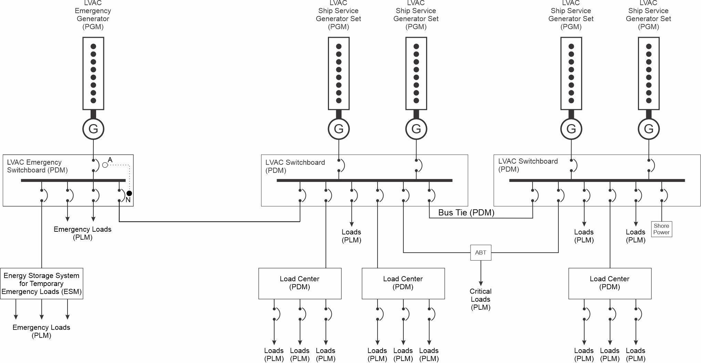
Figure 1: Low Voltage AC Radial Architecture

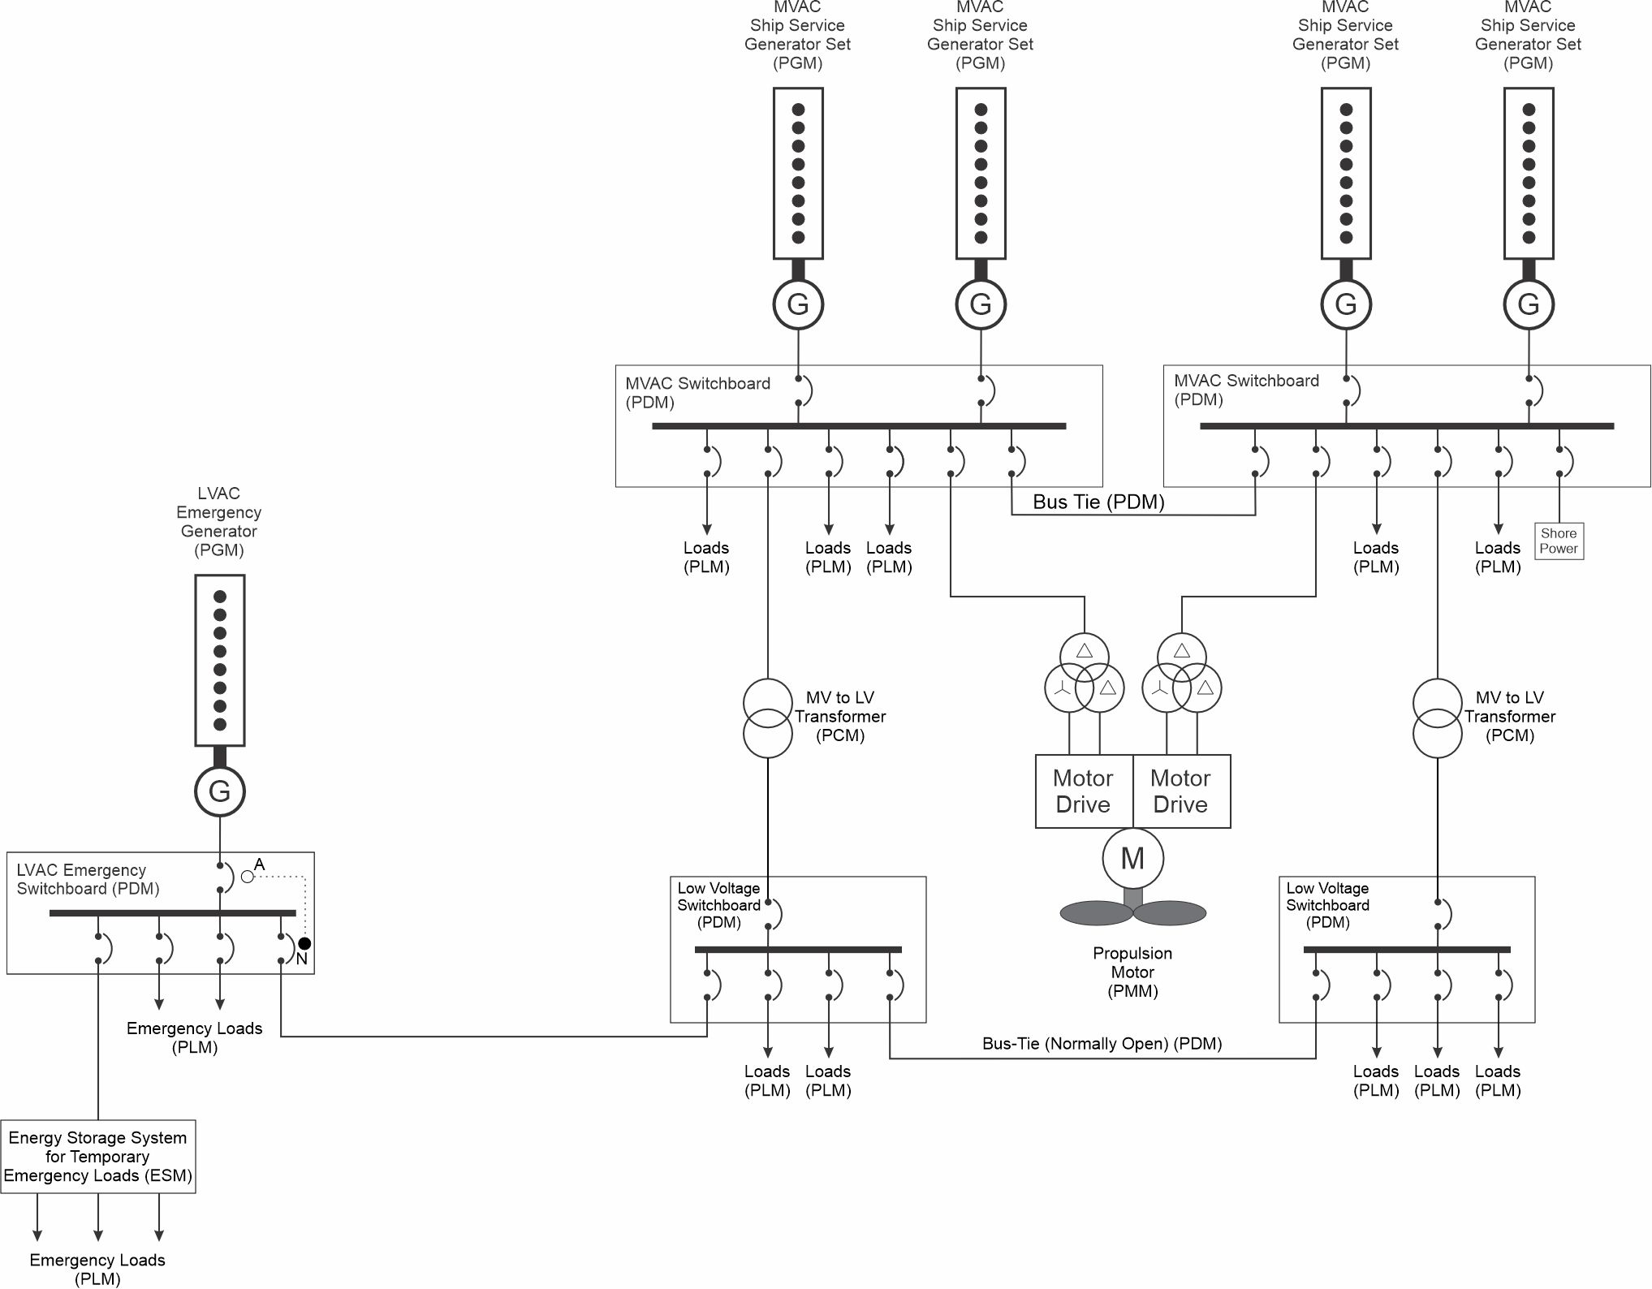
Figure 2: Medium Voltage AC Radial Architecture
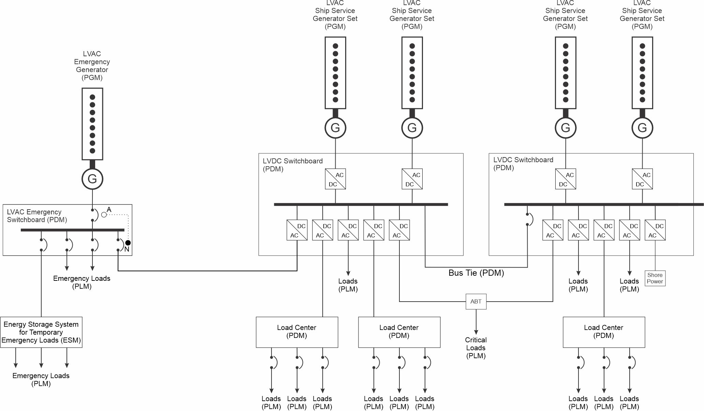
Figure 3: Low Voltage DC Radial Architecture
  - Advantages and Disadvantages
The biggest advantage to radial systems is their simplicity. In many commercial ships, all the ship service generators and the main switchboards are located in the same machinery room (only the emergency generator with its switchboard is located in a distant location). Having all the equipment together facilitates watchstanding and allows for compact machinery arrangements.
In ships requiring increased levels of survivability, the two main switchboards may be separated by A-60 bulkheads that resist the spread of fire through the bulkheads for 60 minutes.
The disadvantages of radial distribution systems include:
- Long feeder cables from the switchboards to the loads at the other end of the ship add weight and are susceptible to damage.
- Critical loads powered via ABTs at the load require two cables to the main switchboards; these cables can be very long and add weight.
- Both switchboards may be susceptible to being placed out of service from the same cause. If in the same watertight subdivision, flooding can impact both switchboards (and all the ship service generator sets)
- Many loads may not be energized when maintenance is performed on a single switchboard.
  - Applications
Many commercial cargo ships and offshore platforms employ a radial distribution system due to its simplicity; radial distribution systems meet minimum regulatory and classification society rules. Naval auxiliaries and smaller (frigate sized and below) naval combatants may have radial distribution systems.
- Ring architecture
  - Design
A ring bus architecture is similar to a radial architecture with the following exceptions:
- Not every switchboard need have an associated source.
- The switchboards are connected in a ring such that power connectivity is maintained with all switchboards with the loss of an arbitrary bus-tie.
A ring bus architecture is normally operated for parallel plant operation with all bus-ties closed. The selective opening of bus-ties does enable split-plant operation; the ring bus architecture enables a quick recovery of power to a switchboard due to loss of an arbitrary bus-tie.
Figure 4 depicts an example of a low voltage ring bus architecture. Note that one switchboard does not have a source associated with it. It does however, provide better connectivity between the emergency switchboard and the two switchboards with ship service generator sets.
Figure 5 depicts a medium voltage ring bus architecture. The bus ties between the LV switchboards would normally be open (disconnected); the bus ties are used if the transformer between an MV and LV switchboard is out of service.
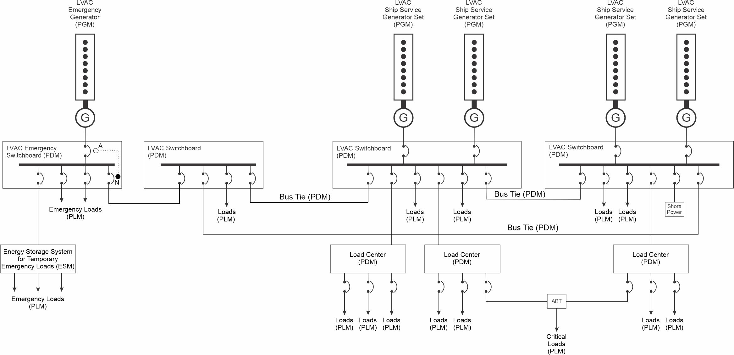
Figure 4: Low Voltage AC Ring Bus Architecture
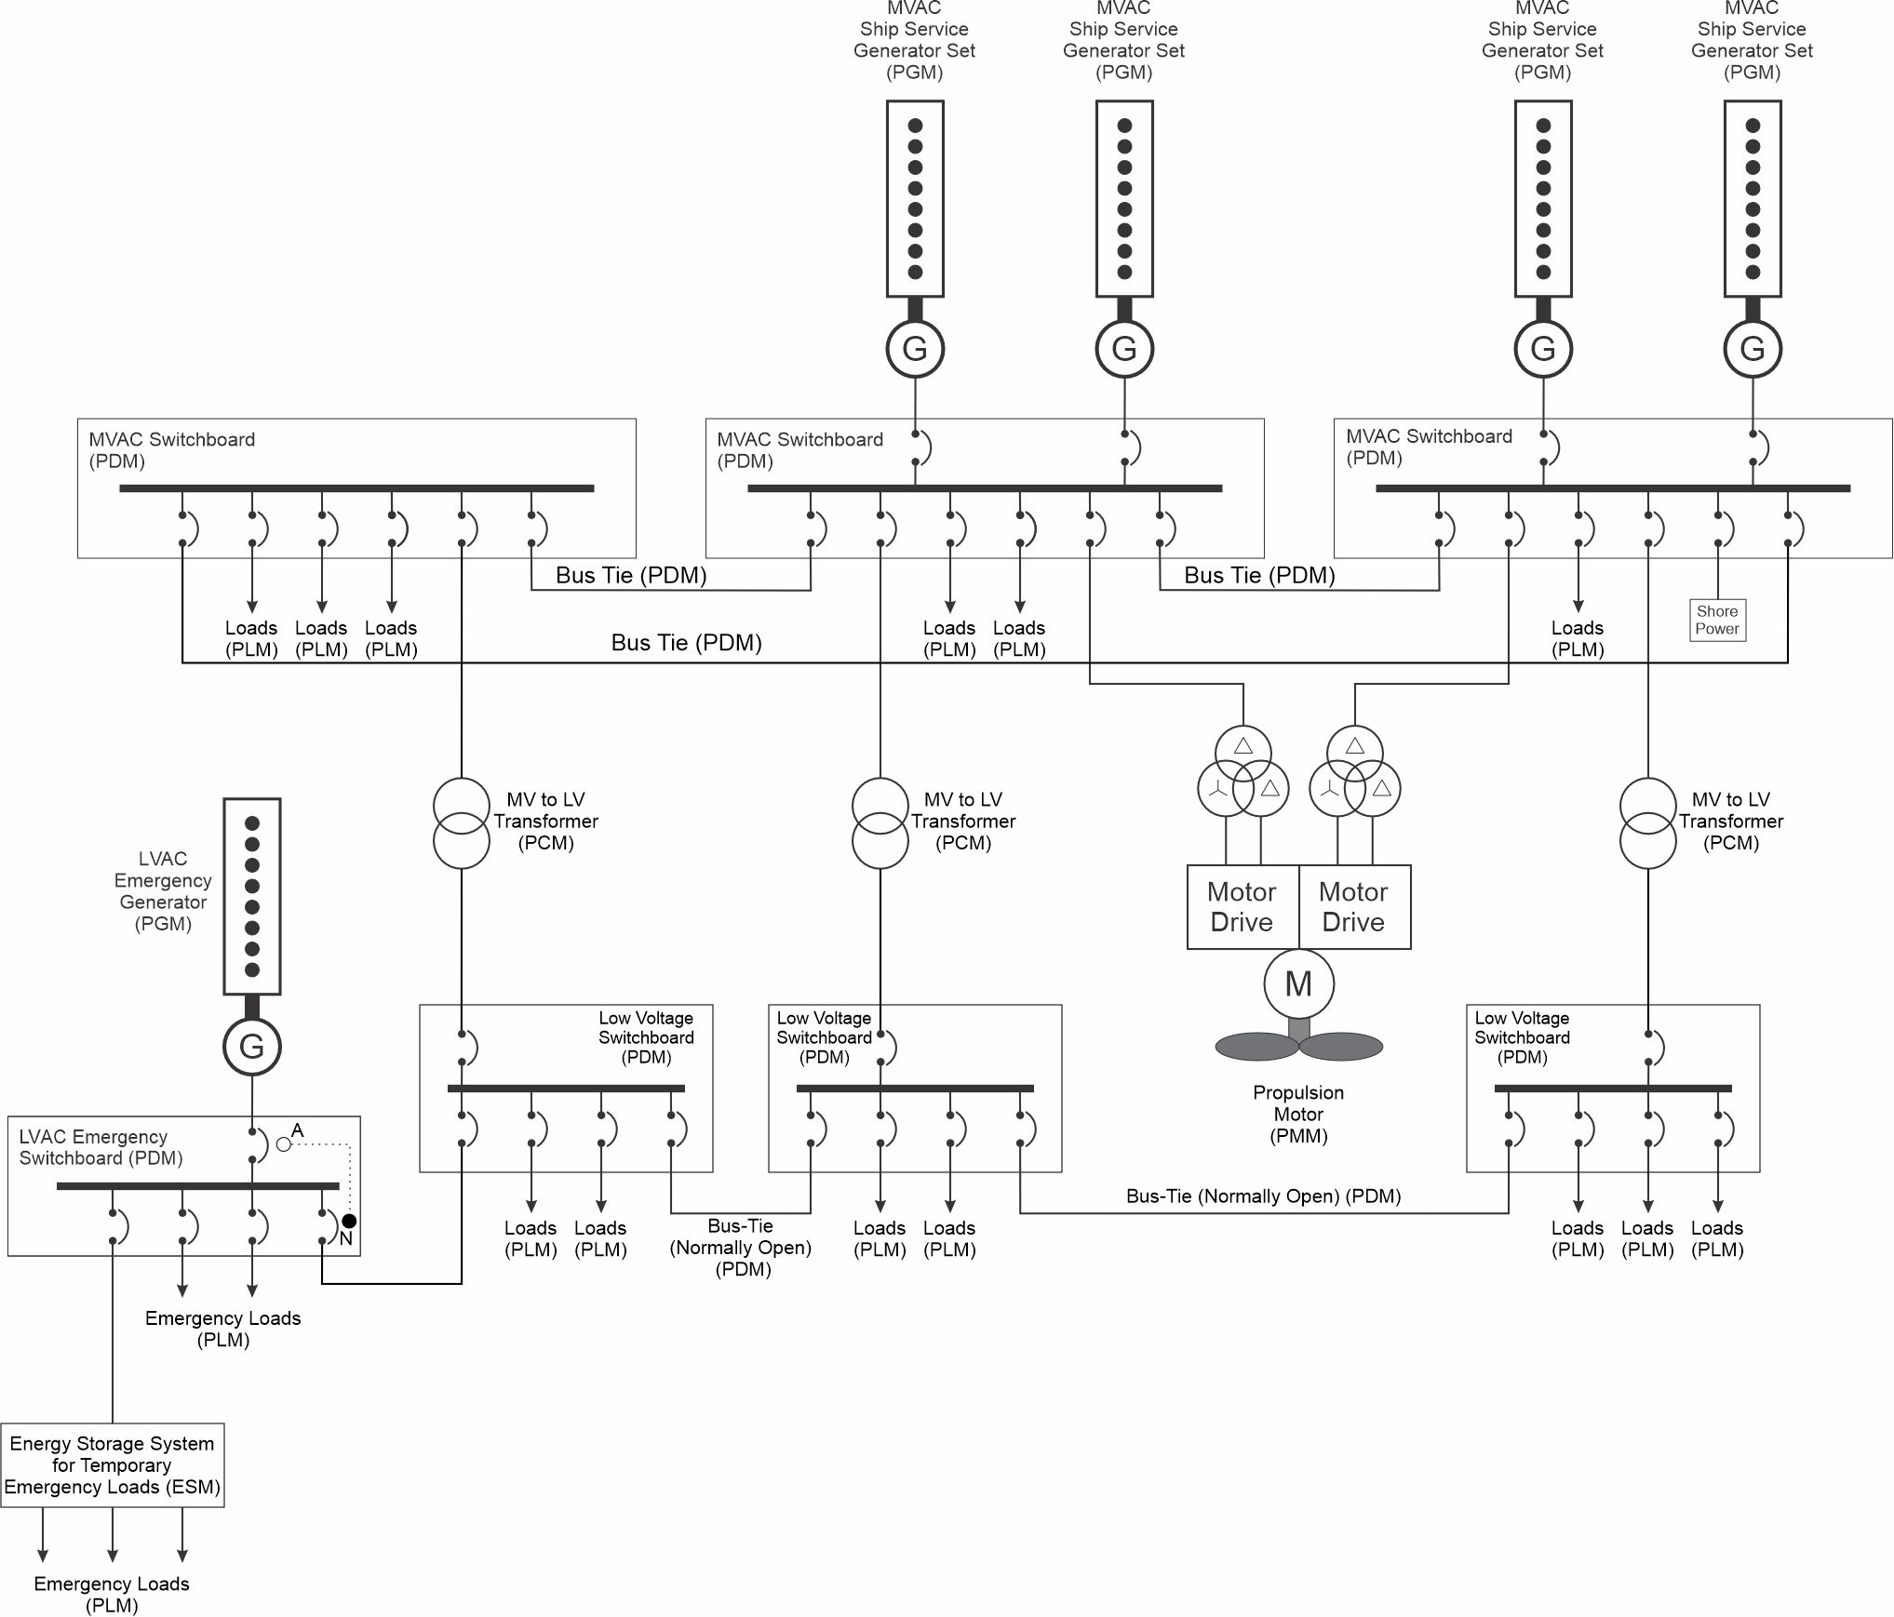
Figure 5: Medium Voltage AC Ring Bus Architecture
  - Advantages and Disadvantages
The main advantage of a ring bus is the improvement in reliability and survivability of the power system. Power connectivity can be maintained with the loss of any bus-tie breaker.
By incorporating additional switchboards in different parts of the ship, the length of feeder cables to individual loads and load centers can be shortened. Although a ring bus includes additional bus ties, the total amount of cable installed onboard the ship is usually less. From an arrangements perspective, room must be found for the additional switchboards.
In medium voltage applications, the additional medium voltage to low voltage transformers enables reducing the rating of each transformer. Generally, with one transformer out of service, the capacity of the remaining transformers should be sufficient to serve all low voltage ship service loads. With only two transformers, each transformer should individually have the capacity to serve all the loads. With three transformers, each transformer need only have the capacity to serve 50% of the load (assuming loads can be evenly split among the remaining transformers). Because transformer weight does not scale linearly with rated power, the three transformers, each rated at 50% of the load should together weigh roughly the same as two transformers, each rated at 100% of the load.
Circuit protection for a ring bus requires more a more complicated design due to the lack of unidirectional power flow within the bus-ties comprising the ring bus. Typically, differential protection, or directional protection is employed instead of simple time vs fault current curves.
  - Applications
Ring bus architectures are generally found on ships with large, distributed, electric loads. Ring bus architectures are also applicable to ships that are required by SOLAS to be capable of a ship’s safe return to port following a fire casualty or flooding of any single watertight compartment. Examples include large cruise ships, naval warships, and large high-power offshore platforms.
- Zonal architecture
  - Design
A zonal architecture is similar to a ring bus architecture with the following exceptions:
- The ship is divided geographically into multiple zones.
- The ring bus may be configured as a port and starboard bus. Each bus is segmented by switchboards that provide power to load centers, possibly via a PCM. A zone is not required to have a switchboard; a load center may be powered by switchboard in another zone.
- In ships with medium voltage generation, the ring bus is operated at medium voltage. A medium to low voltage transformer or power electronic converter (PCM) is connected to a medium voltage switchboard that is part of the ring bus, and a dedicated low voltage switchboard that provides power to load centers. The low voltage switchboards may or may not have bus-ties with other low voltage switchboards.
- Sources are typically, but not always, connected to a generator switchboard that may be configured to connect to either the port or starboard bus.
- The port and starboard buses, if provided, may be interconnected in several places to enable parallel operation. Typically, split plant operation is used such that the port and starboard buses operate independently.
- All loads are powered by load centers or switchboards within the zone. Critical loads typically have a normal connection to a load center or switchboard powered from one bus (port or starboard), and an alternate connection to a load center or switchboard powered by the other bus.
- The power system is designed to provide zonal survivability. In zonal survivability, damage and loss of two adjacent zones does not impact the ability to provide power (and other distributed system services) to the remaining undamaged zones. Generally, the port and starboard buses are protected such that even if the zone they are in is damaged, at least one of the two buses is likely to survive and function.
Figure 6 depicts an example of a low voltage zonal architecture for naval applications. Naval ships often do not have an emergency generator or an emergency distribution system; every generator set can function as an emergency generator. Loads usually connect to load centers, but some may connect directly to a switchboard. Emergency and other critical loads employ automatic or bus transfers to connect to a normal source of power or to an alternate source of power if the normal source of power is not available. The normal and alternate sources of power should connect to different buses; if the connection of the load centers to the bus are not in the same zone as the load, then, if possible, one load center should be connected forward of the load’s zone and the other aft of the load’s zone.
For this example, zone 1 is at the bow of the ship, and the zones are numbered in sequence going aft. The switchboards at the bottom of the figures comprise the starboard bus and the switchboards at the top of the figure comprise the port bus. For zonal systems, loads should connect to switchboards or load centers within their zone. While this example shows two load centers per zone, a zone may have more than two load centers.
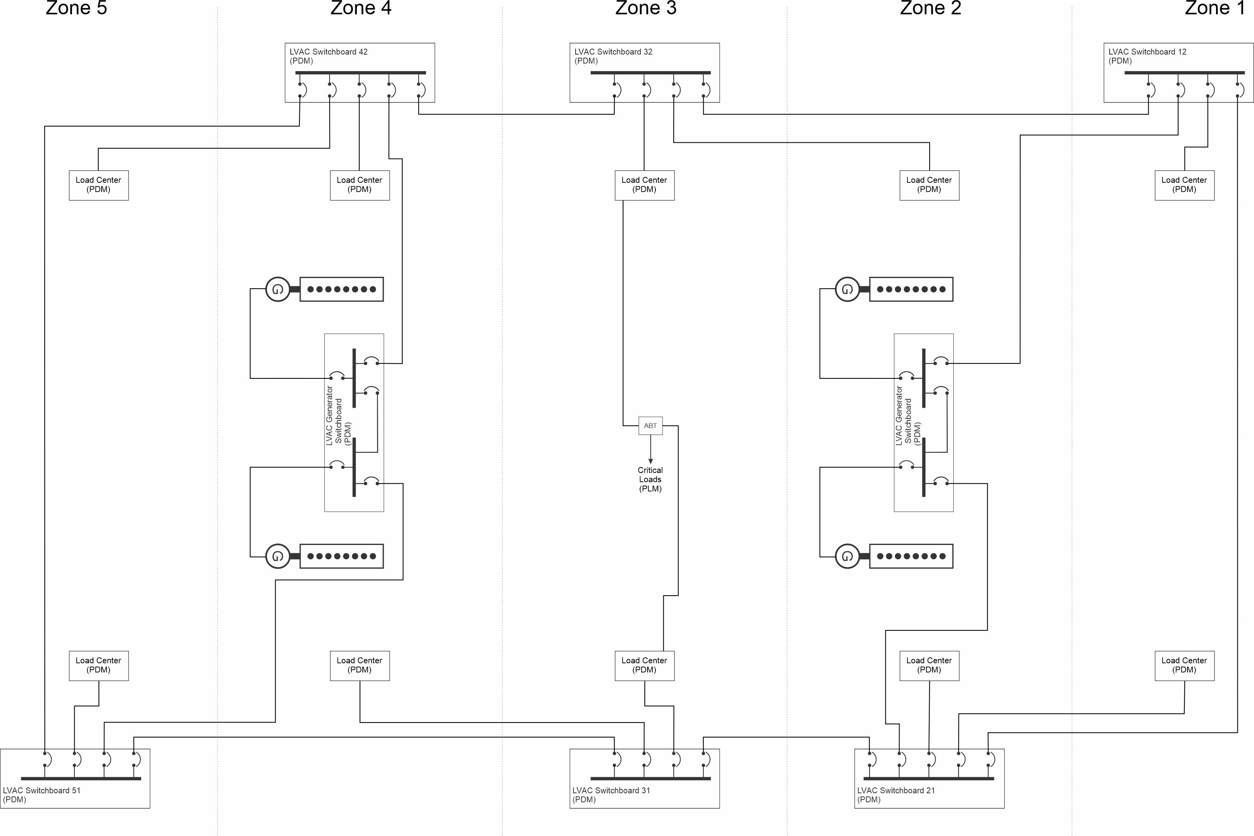
Figure 6: Low Voltage AC Zonal Architecture
Figure 7 depicts the implementation of a LVAC zonal architecture for a commercial ship where zonal survivability is only required for the emergency loads. This architectural may be appropriate for high value ships where continued operation following a damaging condition is not required, but survival of the ship is highly desired. The architecture can also be desirable if each zone is intended to be of a standard design for multiple applications; the segmented emergency switchboards minimize the number of cables crossing zone boundaries.
The switchboards for the ship service loads are configured in a ring bus; the ship service generators are provided power from generator sets connected to two of the switchboards on the ring bus. An emergency switchboard is located in each zone. For all zones other than the one containing the emergency generator, the normal supply for the emergency switchboard is from a ship service switchboard and its alternate supply is the emergency switchboard in the next zone closer to the emergency generator. For the zone containing an emergency generator, the normal supply is the ship service switchboard and the alternate supply is the emergency generator. With this configuration, the emergency generator is only able to supply power to emergency loads in accordance with 46 CFR 112.
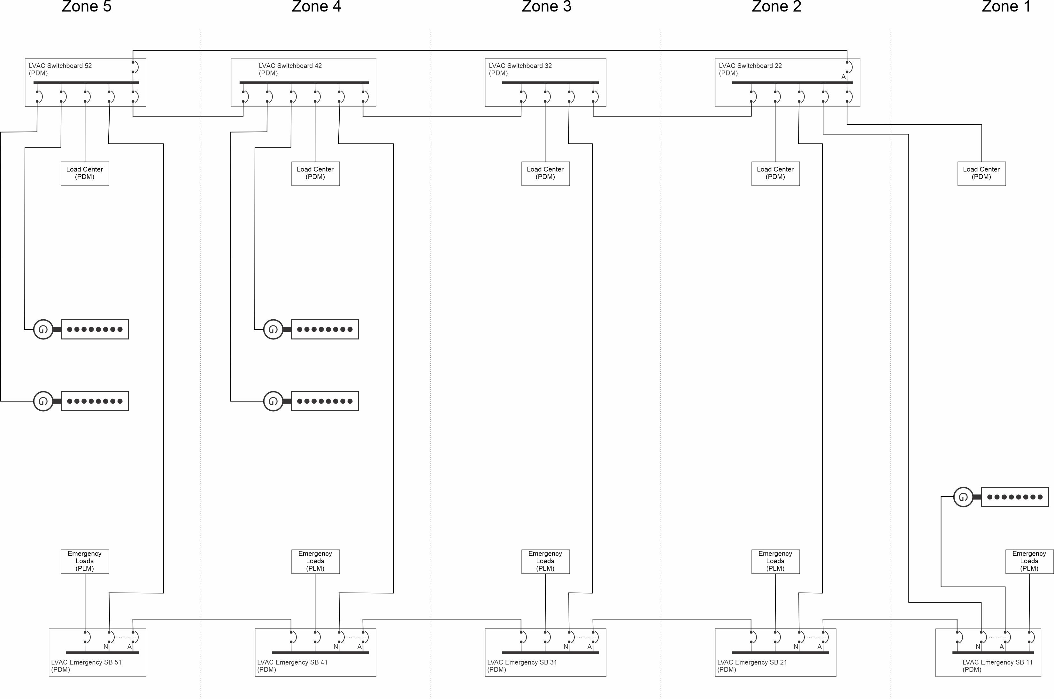
Figure 7: Low Voltage AC Zonal Architecture – Emergency Bus
The number of zones and the boundaries between zones are total ship design decisions. The ship designer should consider the following when establishing the number and boundaries of the zones:
- Zones should be large enough such that non-overmatching damage to the ship due to an initiating event (such as grounding, collision, fire, or weapon effects) does not extend beyond two adjacent zones. Ships are not designed to survive overmatching damage.
- Zone boundaries should be designed to preclude fire spreading or progressive flooding to extend beyond the initial one or two damaged zones. Zone boundaries should be watertight and should have an A-60 fire rating as defined by SOLAS Chapter II-2. The fire protection system should be designed to detect and extinguish fires within 60 minutes.
- For ships required by SOLAS to have the capability for safe return to port, the casualty threshold for fire is no larger than a single zone. In a similar manner, the flooding requirement of any single watertight compartment is also no larger than a single zone. The boundaries of zones should be selected such that the systems required to remain operational by SOLAS have sufficient redundancy across zones.
- With any two adjacent zones damaged, there should be sufficient capability remaining in the undamaged zones to achieve the survivability objectives of the ship.
- For systems required to be operational following damage and have multiple single points of failure, the single points of failure should ideally be located in the same zone.
- For systems required to be operational following damage and have redundancy, the redundant capability should ideally be located in different zones that are not adjacent.
- A ship with a two-compartment damaged stability requirement can satisfy the flooding criteria with zones that span at least a single watertight subdivision. A ship with a three-compartment damaged stability requirement can satisfy the flooding criteria with zones that span at least two watertight subdivisions.
Figure 8 depicts a medium voltage ac variant of a zonal ac distribution system. Transformers at each medium voltage switchboard supply power to low voltage load centers. Otherwise, the architecture is similar to the low voltage ac zonal distribution system. In Figure 9, the transformers are replaced with power electric ac to ac converters. These converters can prevent disturbances and power quality issues within a zone from propagating outside the zone; similarly, disturbance and power quality issues outside a zone can be prevented from propagating inside the zone. By regulating the low voltage output of the converter, excessive voltage drop at the load interfaces is unlikely to happen.
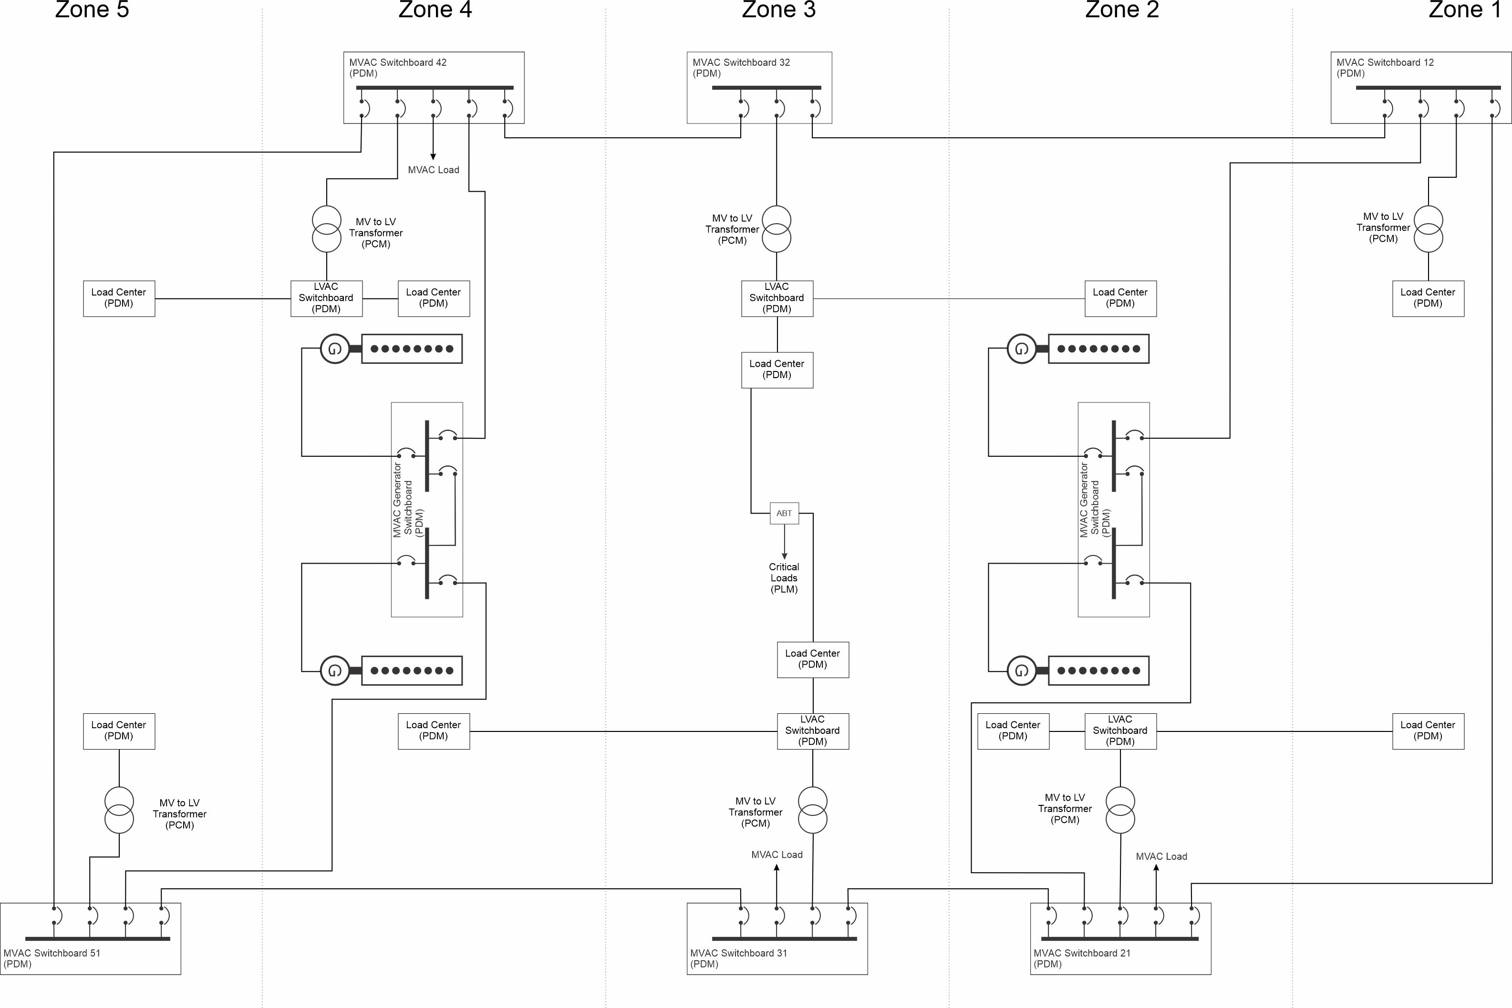
Figure 8: Medium Voltage AC Zonal Architecture
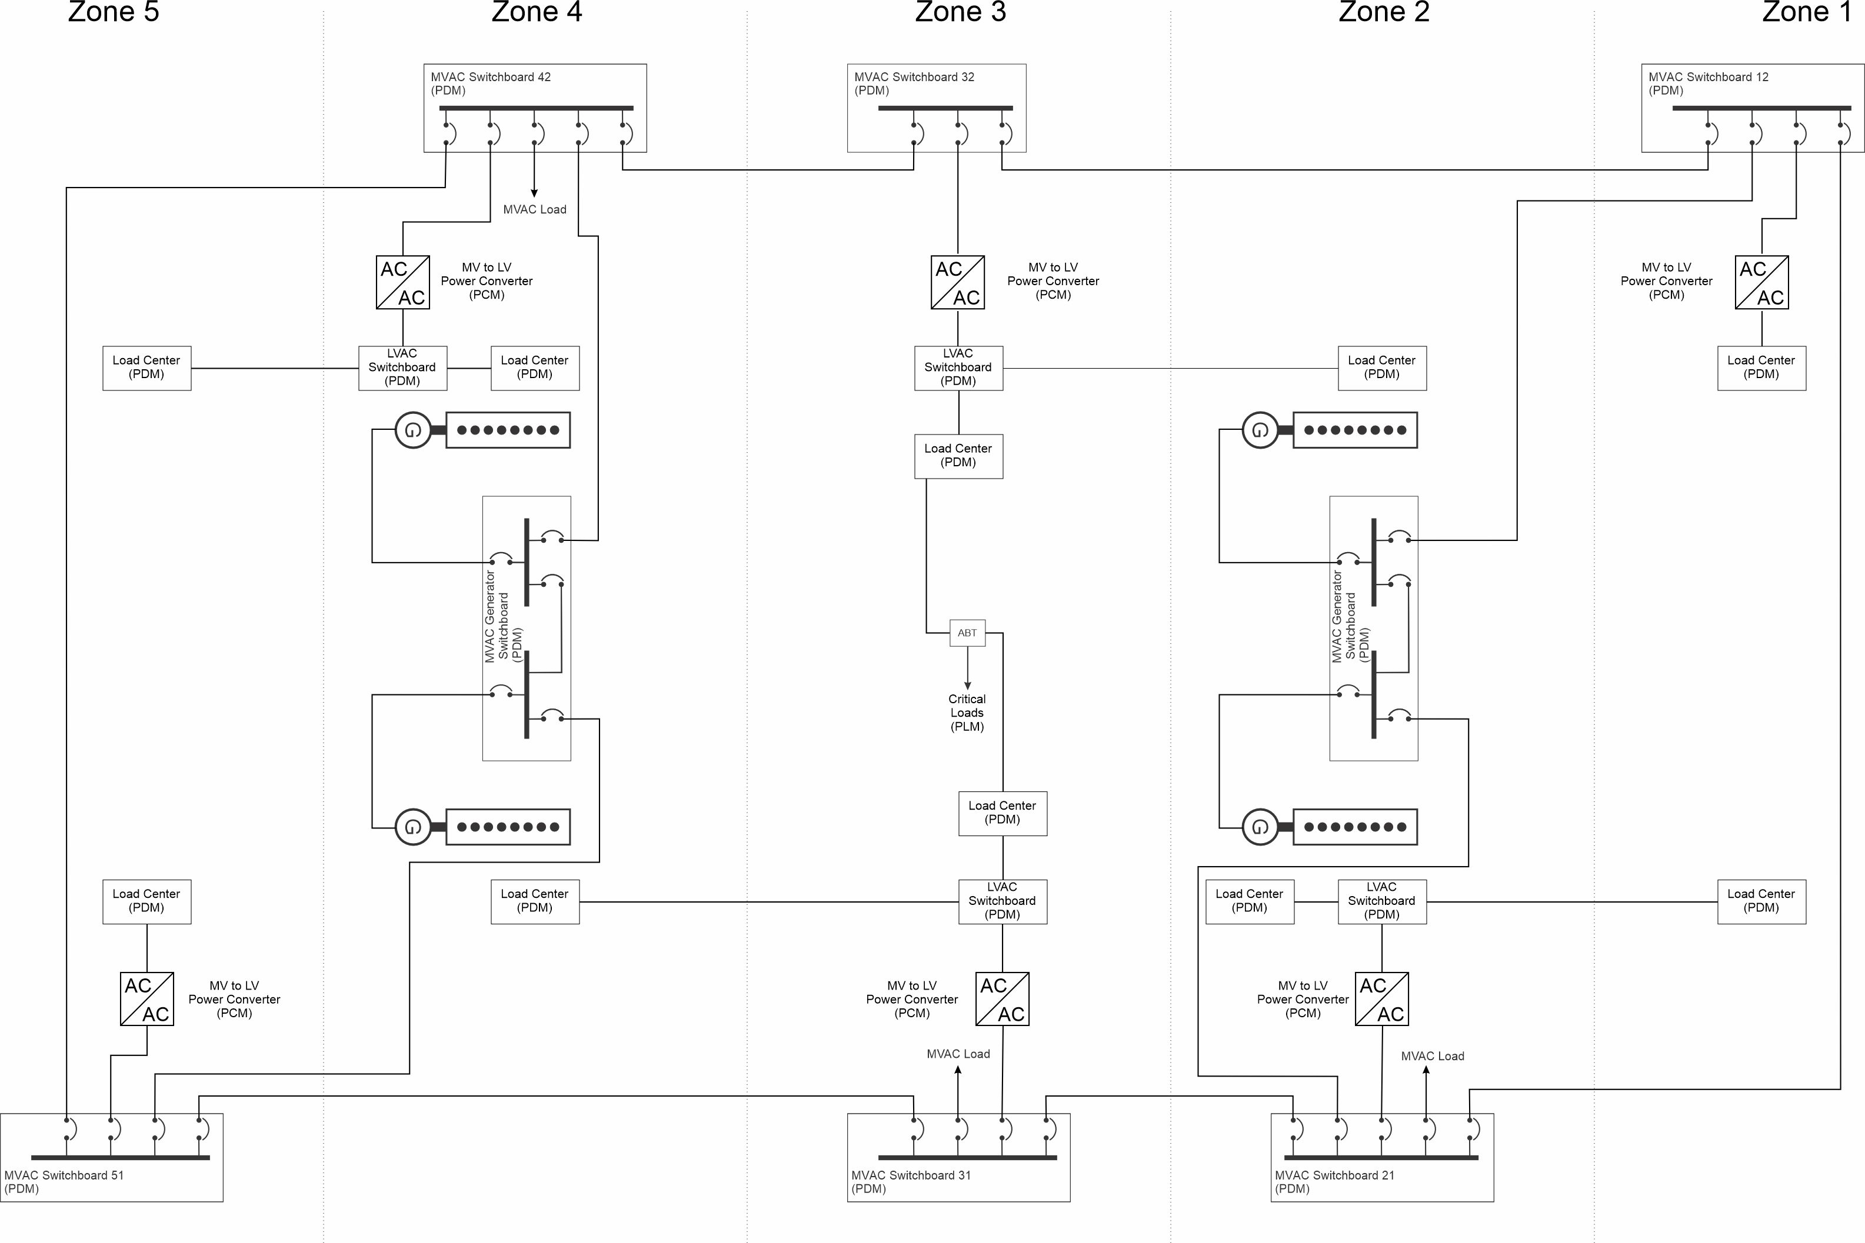
Figure 9: Medium Voltage AC Zonal Architecture with power electronic converters
  - Advantages and Disadvantages
Advantages of a zonal distribution system include:
- For mission critical loads, normal and alternate feeder cables are typically shorter since they do not cross zone-boundaries.
- Enables zonal survivability which can ensure a level of survivability by design rather than the traditional method of proposing a solution and then confirming (or not) survivability by analysis.
- Simplifies operational awareness since unexpected behavior should be isolated to only the damaged zones. Undamaged zones should not experience a degradation of service to mission critical loads.
- Prevents cascading faults due to misalignment of individual distributed system zone boundaries.
- Enables zone designs to be re-used across ship design applications; for the most part, modifications to the electrical system are only required in the zones where modifications to other systems are made.
- Enables designing power systems so that the power systems within a zone can be energized prior to the ship zone being integrated with the remainder of the ship; thereby reducing the amount of temporary services required for lighting, ventilation, and electric power.
Disadvantages of a zonal distribution system include:
- A possible increase in the total number of switchboards as compared to radial and ring bus architectures.
- In common with ring buses, circuit protection for a zonal distribution system may require a more complicated design due to the lack of unidirectional power flow within the bus-ties. Typically, differential protection, or directional protection is employed instead of simple time vs fault current curves.
  - Applications
Zonal distribution systems are appropriate for naval warships, complex commercial ships, and commercial ships that are required to accommodate safe return to port capabilities. Zonal distribution systems may also be attractive if design re-use is intended for ship zones among multiple ship designs; the number of distributed system connections between zones can be minimized.
- Dynamic Positioning
Dynamic positioning (DP) operation is defined by the IMO to mean “using the DP system to control at least two degrees of freedom in the horizontal plane automatically.” The DP system is comprised of the electrical power system, thruster system, and DP control system. If the rudders and main propulsion are incorporated into the DP control system, then the rudder and main propulsion are considered part of the thruster system. IMO defines three classes of DP systems; the ABS Guide for Dynamic Positioning Systems aligns its classification notations DPS-1, DPS-2, and DPS-3 to the IMO classes. ABS also defines an additional DPS-0 classification notation. The ABS definitions for its classification notations are:
“DPS-0 For vessels which are fitted with centralized manual position control and automatic heading control system to maintain the position and heading (Station Keeping) under the specified maximum environmental conditions.
DPS-1 For vessels which are fitted with a dynamic positioning system which is capable of automatically maintaining the position and heading (Station Keeping) of the vessel under specified maximum environmental conditions having a manual position control system.
DPS-2 For vessels which are fitted with a dynamic positioning system which is capable of automatically maintaining the position and heading (Station Keeping) of the vessel within a specified operating envelope under specified maximum environmental conditions during and following any single fault, excluding a loss of compartment or compartments.
DPS-3 For vessels which are fitted with a dynamic positioning system which is capable of automatically maintaining the position and heading (Station Keeping) of the vessel within a specified operating envelope under specified maximum environmental conditions during and following any single fault, including complete loss of a compartment due to fire or flood.”
DPS-2 and DPS-3 levy requirements on the electrical system architecture; DPS-3 also places constraints on where electrical power system components are located. DPS-2 and DPS-3 both require redundancy within the thruster system and within the electrical distribution system. All of the architectures discussed in this document are likely to be capable of meeting the demands of DPS-2 and DPS-3; by implementing zonal survivability, it may be easier to demonstrate the required system resiliency with a zonal distribution system.

- References
ABS Guide for Dynamic Positioning Systems
IEEE Std 45.1 IEEE Recommended Practice for Electrical Installations on Shipboard--Design
IEEE Std 45.3 IEEE Recommended Practice for Electrical Installations on Shipboard--Systems Engineering
NFPA 70 National Electrical Code
Doerry, LCDR Norbert and LCDR James C. Davis, "Integrated Power System for Marine Applications", Naval Engineers Journal, May 1994.
Doerry, LCDR Norbert, Henry Robey, LCDR John Amy, and Chester Petry, "Powering the Future with the Integrated Power System", Naval Engineers Journal, May 1996.
Doerry, Dr. Norbert and Dr. John V. Amy Jr., "Design Considerations for a Reference MVDC Power System," presented at SNAME Maritime Convention 2016, Bellevue, WA, Nov 1-5, 2016.

